BIG DATA PROJECT

H1B VISA APPLICATIONS

CONTENTS

1.Introduction to BigData
2.Evolution of BigData
3.Characteristics of BigData
4.Sources of BigData
5.Applications of BigData
6.Hadoop Introduction
7.Hadoop Ecosystem
8.HDFS(Hadoop Distributed File System)
9.MapReduce
10.Yarn
11.Hive
12.Pig
13.Sqoop
14.Flume
15.Oozie
16.Zookeeper
17.H1B Visa Applications
a.Hive Questions
b.Pig Questions
c.MapReduce Questions
Introduction to BigData
Big data usually includes data sets with sizes beyond the ability of commonly used software tools to capture, curate, manage, and process data within a tolerable elapsed time.Big data "size" is a constantly moving target, as of 2012 ranging from a few dozen terabytes to many petabytes of data.Big data is a set of techniques and technologies that require new forms of integration to uncover large hidden values from large datasets that are diverse, complex, and of a massive scale.
In a 2001 research report and related lectures, META Group (now Gartner) defined data growth challenges and opportunities as being three-dimensional, i.e. increasing volume (amount of data), velocity (speed of data in and out), and variety (range of data types and sources). Gartner, and now much of the industry, continue to use this "3Vs" model for describing big data.
In 2012, Gartner updated its definition as follows: "Big data is high volume, high velocity, and/or high variety information assets that require new forms of processing to enable enhanced decision making, insight discovery and process optimization." Gartner's definition of the 3Vs is still widely used, and in agreement with a consensual definition that states that "Big Data represents the Information assets characterized by such a High Volume, Velocity and Variety to require specific Technology and Analytical Methods for its transformation into Value".
Then after few years a new V "Veracity" is added by some organizations to describe it, revisionism challenged by some industry authorities.

The capacity of data storage has been increasing exponentially, and today with the availability of the cloud infrastructure, potentially one can store unlimited amounts of data. Today Terabytes and Petabytes of data is being generated, captured, processed, stored, and managed.

Evolution of Big Data
Data has always been around and there has always been a need for storage, processing, and management of data, since the beginning of human civilization and human societies. However, the amount and type of data captured, stored, processed, and managed depended then and even now on various factors including the necessity felt by humans, available tools/technologies for storage, processing, management, effort/cost, ability to gain insights into the data, make decisions, and so on.
Going back a few centuries, in the ancient days, humans used very primitive ways of capturing/storing data like carving on stones, metal sheets, wood, etc. Then with new inventions and advancements a few centuries in time, humans started capturing the data on paper, cloth, etc.As time progressed, the medium of capturing/storage/management became punching cards followed by magnetic drums, laser disks, floppy disks, magnetic tapes, and finally today we are storing data on various devices like USB Drives, Compact Discs, Hard Drives, etc.



Characteristics of BigData

BigData is described in 4V’s they are as follows:
1.Volume : It is the size of the data which determines the value and potential of the data under consideration and whether it can actually be considered Big Data or not.
2.Variety : This means that the category to which Big Data belongs to is also a very essential fact that needs to be known by the data analysts.
In today's world, organizations not only need to rely on the structured data from enterprise databases/warehouses, Apart from the traditional flat files, spreadsheets, relational databases etc., we have a lot of unstructured data stored in the form of images, audio files, video files, web logs, sensor data, and many others. This aspect of varied data formats is referred to as Variety in the Big Data world.
3.Velocity : The term ‘velocity’ in the context refers how fast the data is generated and processed to meet the demands and the challenges which lie ahead in the path of growth and development. Trading/stock exchange data, tweets on Twitter, status updates/likes/shares on Facebook, and many others are few examples of Velocity.
4.Veracity : The quality of the data being captured can vary greatly. Accuracy of analysis depends on the veracity of the source data.

Sources of Big Data

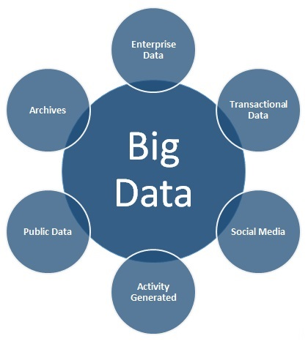

Enterprise Data
There are large volumes of data in enterprises in different formats. Common formats include flat files, emails, Word documents, spreadsheets, presentations, HTML pages/documents, pdf documents, XMLs, legacy formats, etc. This data that is spread across the organization in different formats is referred to as Enterprise Data.

Transactional Data
Every enterprise has some kind of applications which involve performing different kinds of transactions like Web Applications, Mobile Applications, CRM Systems, and many more. To support the transactions in these applications, there are usually one or more relational databases as a backend infrastructure. This is mostly structured data and is referred to as Transactional Data.

Social Media:
This is self-explanatory. There is a large amount of data getting generated on social networks like Twitter, Facebook, etc. The social networks usually involve mostly unstructured data formats which includes text, images, audio, videos, etc. This category of data source is referred to as Social Media.

Formats of Data
Data exists in multiple different formats and the data formats can be broadly classified into two categories - Structured Data and Unstructured Data.
Structured data refers to the data which has a pre-defined data model/schema/structure and is often either relational in nature or is closely resembling a relational model. Structured data can be easily managed and consumed using the traditional tools/techniques.
Unstructured data on the other hand is the data which does not have a well-defined data model or does not fit well into the relational world.
Structured data includes data in the relational databases, data from CRM systems, XML files etc. Unstructured data includes flat files, spreadsheets, Word documents, emails, images, audio files, video files, feeds, PDF files, scanned documents, etc.
Semi-Structured Data : Data which has some structure but cannot be saved in a tabular form in relational databases is known as semi structured data. Example-XML data, email messages etc.
Real-Time Data: Streaming data that needs to analyzed as it comes in. E.g., Intrusion detection.
Data at Rest: Non-real time. E.g., Sales analysis.
Metadata: Definitions, mappings, scheme.

Applications of BigData
- Monitor premature infants to alert when interventions is needed
- Predict machine failures in manufacturing .
- Prevent traffic jams, save fuel, reduce pollution.
- In public services, big data has a very wide range of applications including: energy exploration, financial market analysis, fraud detection, health related research and environmental protection.
- Governments use of big data: traffic control, route planning, intelligent transport systems, congestion management (by predicting traffic conditions)
- Private sector use of big data in transport: revenue management, technological enhancements, logistics and for competitive advantage (by consolidating shipments and optimizing freight movement)
- Amazon Prime, which is driven to provide a great customer experience by offering, video, music and Kindle books in a one-stop shop also heavily utilizes big data

Hadoop Introduction
Hadoop is Open source software framework designed for storage and processing of large scale data on clusters of commodity hardware created by Doug Cutting and Mike Carafella in 2005.Cutting named the program after his son’s toy elephant.
The core of Apache Hadoop consists of a storage part, known as Hadoop Distributed File System (HDFS), and a processing part which is a MapReduce programming model.
Hadoop splits files into large blocks and distributes them across nodes in a cluster. It then transfers packaged code into nodes to process the data in parallel.
This approach takes advantage of data locality, where nodes manipulate the data they have access to. This allows the dataset to be processed faster and more efficiently than it would be in a more conventional supercomputer architecture that relies on a parallel file system where computation and data are distributed via high-speed networking
Hadoop core Components are:
1.Hadoop Distributed File System(HDFS)-Storage Layer
2.MapReduce-Processing Layer

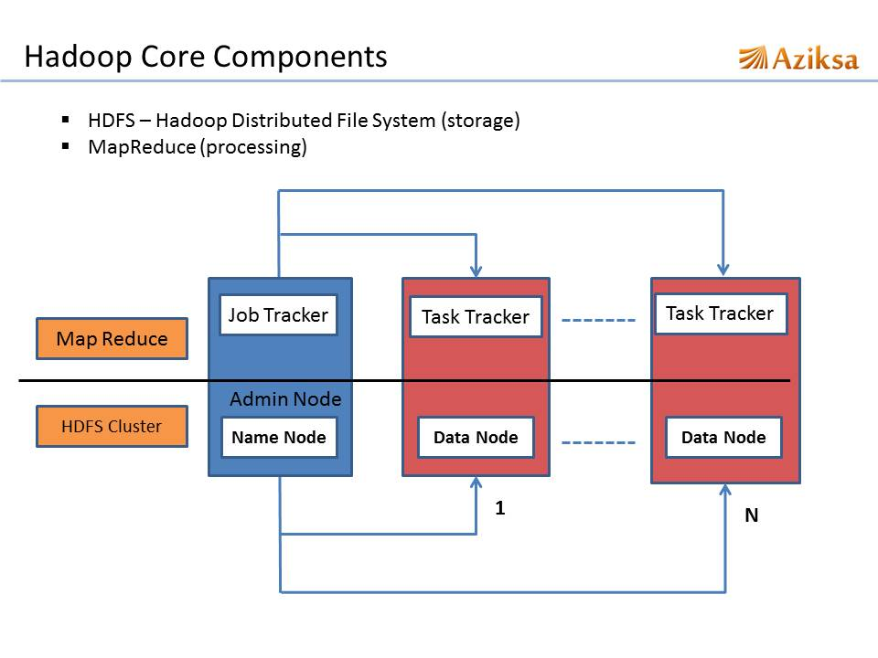
Hadoop EcoSystem

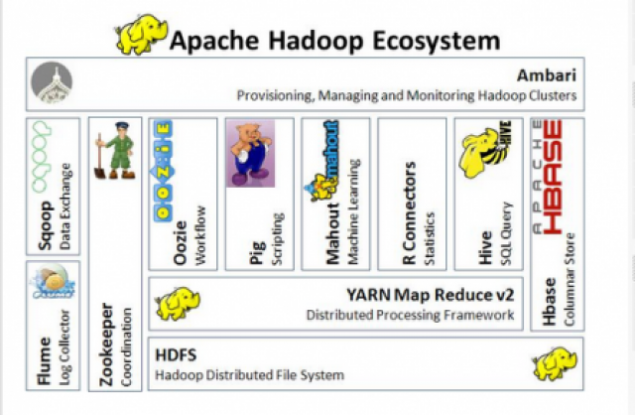

We have many other components in the hadoop ecosystem apart from core components as shown in the figure above we will be discussing about these components in detail:
1.HDFS
2.MapReduce
3.Hive
4.Pig
5.HBASE
6.Oozie
7.Zookeeper
8.Flume
Types of Nodes
1.NameNode:
Master of the system.Maintains and manages the blocks which are present on the DataNodes.
Updates to the file system (add/remove blocks) do not change the fsimage file.They are instead written to a log file
When starting the NameNode loads the fsimage file and then applies the changes in the log file.
2.DataNodes:
Slaves which are deployed on each machine and provide the actual storage.
Responsible for serving read and write requests for the clients
3.Jobtracker:
It takes care of all the job scheduling and assign tasks to Task Trackers.
4.TaskTracker:
a node in the cluster that accepts tasks - Map, Reduce and Shuffle operations - from a jobtracker .
5.Secondary Namenode:
It is a backup for the NameNode
Periodically reads the log file and applies the changes to the fsimage file bringing it up to date
Allows the NameNode to restart faster when required

Hadoop Distributed File System (HDFS)

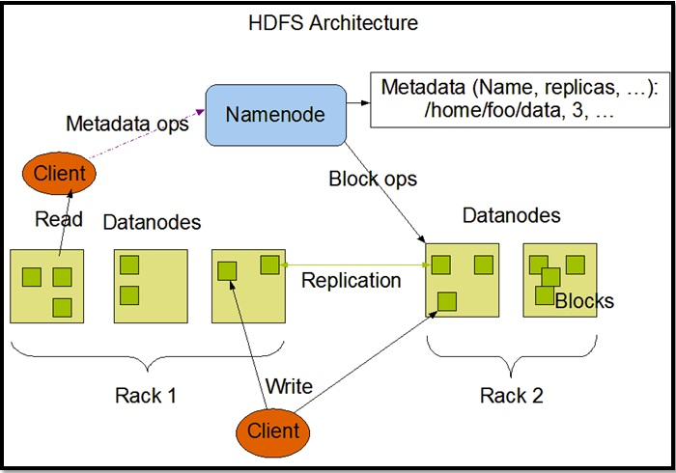

- Hadoop Distributed File System (HDFS) is designed to reliably store very large files across machines in a large cluster. It is inspired by the GoogleFileSystem.
- Distribute large data file into blocks
- Blocks are managed by different nodes in the cluster
- Each block is replicated on multiple nodes
- Name node stored metadata information about files and blocks
- HDFS saves data in a block of 128 MB(default) in size which is logical splitting of data in a Datanode (physical storage of data) in Hadoop cluster(formation of several Datanode which is a collection commodity hardware connected through single network).
HDFS comprises of 3 important components-NameNode, DataNode and Secondary NameNode.
HDFS operates on a Master-Slave architecture model where the NameNode acts as the master node for keeping a track of the storage cluster and the DataNode acts as a slave node summing up to the various systems within a Hadoop cluster
All information about data splits in data node known as metadata is captured in Namenode which is again a part of HDFS.
When a client wants to retrieve data Communicates with the NameNode to determine which blocks make up a file and on which data nodes those blocks are stored.

HDFS Use Case-

Nokia deals with more than 500 terabytes of unstructured data and close to 100 terabytes of structured data.

Nokia uses HDFS for storing all the structured and unstructured data sets as it allows processing of the stored data at a petabyte scale.

MAPREDUCE
- It is another main component of Hadoop and a method of programming in a distributed data stored in a HDFS.

- We can write Map reduce program by using any language like JAVA, C++ PIPEs, PYTHON, RUBY etc.

- By name only Map Reduce gives its functionality Map will do mapping of logic into data (distributed in HDFS) and once computation is over reducer will collect the result of Map to generate final output result of MapReduce.

- MapReduce Program can be applied to any type of data whether Structured or Unstructured stored in HDFS. Example - word count using MapReduce

- The basic principle of operation behind MapReduce is that the “Map” job sends a query for processing to various nodes in a Hadoop cluster and the “Reduce” job collects all the results to output into a single value.

- Map Task in the Hadoop ecosystem takes input data and splits into independent chunks and output of this task will be the input for Reduce Task.

- In The same Hadoop ecosystem Reduce task combines Mapped data tuples into smaller set of tuples. Meanwhile, both input and output of tasks are stored in a file system. MapReduce takes care of scheduling jobs, monitoring jobs and re-executes the failed task.

Mapper:
- Reads data as key/value pairs
-The key is often discarded
- Outputs zero or more key/value pairs .
Shuffle and Sort:
- Output from the mapper is sorted by key
- All values with the same key are guaranteed to go to the same machine
Reducer:
- Called once for each unique key
- Gets a list of all values associated with a key as input
- The reducer outputs zero or more final key/value pairs

MapReduce Use Case:

Skybox has developed an economical image satellite system for capturing videos and images from any location on earth.
Skybox uses Hadoop to analyse the large volumes of image data downloaded from the satellites.
The image processing algorithms of Skybox are written in C++.
Busboy, a proprietary framework of Skybox makes use of built-in code from java based MapReduce framework

MapReduce Example :WordCount

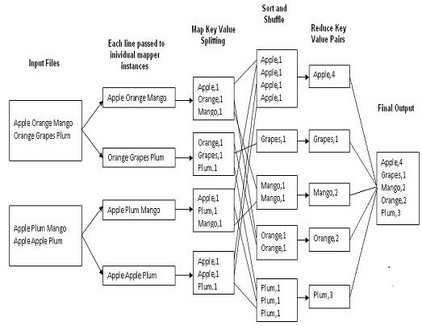

YARN

YARN (Yet Another Resource Negotiator) is a new component added in Hadoop 2.0

In MapReduce framework, MapReduce job (MapReduce application) is divided between number of tasks called mappers and reducers. Each task runs on one of the machine (DataNode) of the cluster, and each machine has a limited number of predefined slots (map slot, reduce slot) for running tasksconcurrently.
Here, JobTracker is responsible for both managing the cluster's resources and driving the execution of the MapReduce job. It reserves and schedules slots for all tasks, configures, runs and monitors each task, and if a task fails, it allocates a new slot and reattempts the task. After a task finishes, the job tracker cleans up temporary resources and releases the task's slot to make it available for other jobs.
Problems with this approach in Hadoop 1.0:
1.It limits scalability: JobTracker runs on single machine doing several task like
  - Resource management
  - Job and task scheduling
  - Monitoring
2.Availability Issue: In Hadoop 1.0, JobTracker is single Point of availability. This means if JobTracker fails, all jobs must restart.
3.Limitation in running non-MapReduce Application:

a.Problem in performing real-time analysis: MapReduce is batch driven. What if I want to do perform real time analysis instead of batch-processing ,There are many applications which need results in real time like fraud detection algorithm. There are real time engines like Apache Storm which can work better in this case. But in Hadoop 1.0, due to tight coupling these engines cannot run independently.

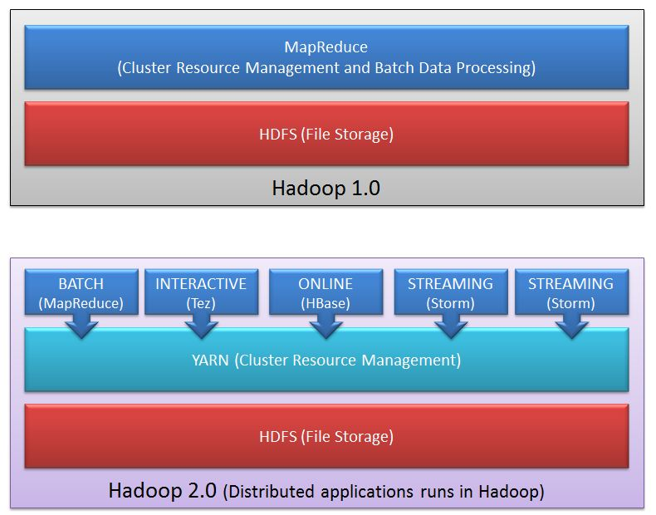
b.Problem in running Ad-hoc query: Many users like to query their big data using SQL. Apache Hive can execute a SQL query as a series of MapReduce jobs, but it has shortcomings in terms of performance.
Recently, some new approaches such as Apache Tajo , Facebook's Presto and Cloudera's Impala drastically improve the performance, but they require to run services in other form than MapReduce form.
It is not possible to run all such non Map Reduce jobs on Hadoop Cluster.

Advantages of YARN:
1.Yarn does efficient utilization of the resource.
There are no more fixed map-reduce slots. YARN provides central resource manager. With YARN, you can now run multiple applications in Hadoop, all sharing a common resource.
2.Yarn can even run application that do not follow MapReduce model.
YARN decouples MapReduce's resource management and scheduling capabilities from the data processing component, enabling Hadoop to support more varied processing approaches and a broader array of applications.

Few Important Notes about YARN:

1.YARN is backward compatible.
This means that existing MapReduce job can run on Hadoop 2.0 without any change.

2.No more JobTracker and TaskTracker needed in Hadoop 2.0:
JobTracker and TaskTracker has totally disappeared. YARN splits the two major functionalities of the JobTracker i.e. resource management and job scheduling/monitoring into 2 separate daemons (components).
  - Resource Manager
  - Node Manager(node specific)

HIVE

- Many programmers and analyst are more comfortable with Structured Query Language than Java or any other programming language for which Hive is created by Facebook and later donated to Apachefoundation.
- Hive mainly deals with structured data which is stored in HDFS with a Query Language similar to SQL and known as HQL (Hive Query Language).
- Hive also run Map reduce program in a backend to process data in HDFS but here programmer has not worry about that backend MapReduce job it will look similar to SQL and result will be displayed on console.
- In Our Hive we almost worked on Hive tables and analytic work by using some built in transformations in our hive ecosystem,But all the time hive built in transformations will not support for our requirement,at that time we have write our own user defined function in hive also called as UDFs in hive .

- Hive is not a relational database, a design for OnLine Transaction Processing (OLTP), language for real-time queries and row-level updates.

HIVE QL Example:
Hive>SELECT customerId, max(total_cost) from hive_purchases GROUP BY customerId HAVING count(*) > 3;

Hive Use Case-
Hive simplifies Hadoop at Facebook with the execution of 7500+ Hive jobs daily for Ad-hoc analysis, reporting and machine learning

CommonPoints Of Pig And Hive:

- Both requires compiler to generate Map reduce jobs
- Hence high latency queries when used for real time responses to ad-hoc queries
- Both are good for batch processing and ETL jobs
- Fault tolerant

PIG

- PIG also deals with structured data using PIG LATIN language. PIG was originally developed at Yahoo to answer similar need to HIVE.
- It is an alternative provided to programmer who loves scripting and don't want to use Java/Python or SQL to process data.
- A Pig Latin program is made up of a series of operations, or transformations, that are applied to the input data which runs MapReduce program in backend to produce output.

Pig Latin example:
A = LOAD 'student' USING PigStorage(‘,’) AS (name:chararray, age:int, gpa:float);
X = FOREACH A GENERATE name,$2;
DUMP X;

Pig Use Case-

The personal healthcare data of an individual is confidential and should not be exposed to others.
This information should be masked to maintain confidentiality but the healthcare data is so huge that identifying and removing personal healthcare data is crucial.
Apache Pig can be used under such circumstances to de-identify health information

SQOOP

- ​​Sqoop component is used for importing data from external sources into related Hadoop components like HDFS, HBase or Hive.

- It can also be used for exporting data from Hadoop other external structured data stores.

- Sqoop parallelized data transfer, mitigates excessive loads, allows data imports, efficient data analysis and copies data quickly

Hadoop
sqoop
RDBMS

Sqoop Use Case:

Online Marketer Coupons.com uses Sqoop component of the Hadoop ecosystem to enable transmission of data between Hadoop and the IBM Netezza data warehouse and pipes backs the results into Hadoop using Sqoop.

- The dataset being transferred is broken into small blocks.
- Individual mapper is responsible for transferring a block of the dataset.

FLUME

- ​Flume component is used to gather and aggregate large amounts of data.
- Apache Flume is used for collecting data from its origin and sending it back to the resting location (HDFS).
- Flume accomplishes this by outlining data flows that consist of 3 primary structures channels, sources and sinks.
- The processes that run the dataflow with flume are known as agents and the bits of data that flow via flume are known as events.

Flume Use Case :

- Twitter source connects through the streaming API and continuously downloads the tweets (called as events).
- These tweets are converted into JSON format and sent to the downstream Flume sinks for further analysis of tweets and retweets to engage users on Twitter.

Data Storage Component of Hadoop Ecosystem –HBase

HBASE :

- HBase is a column-oriented database that uses HDFS for underlying storage of data.
- HBase supports random reads and also batch computations using MapReduce.
- With HBase NoSQL database enterprise can create large tables with millions of rows and columns on hardware. machine.
- The best practice to use HBase is when there is a requirement for random read or write’ access to big datasets .

HBase Use Case-

- Facebook is one the largest users of HBase with its messaging platform built on top of HBase in 2010.
- HBase is also used by Facebook for streaming data analysis, internal monitoring system, Nearby Friends Feature, Search Indexing and scraping data for their internal data warehouses.

Monitoring,Managing Component of Hadoop Ecosystem:

OOZIE:

- ​Oozie is a workflow scheduler where the workflows are expressed as Directed Acyclic Graphs.
- Oozie runs in a Java servlet container Tomcat and makes use of a database to store all the running workflow instances, their states ad variables along with the workflow definitions to manage Hadoop jobs (MapReduce, Sqoop, Pig and Hive).
- The workflows in Oozie are executed based on data and time dependencies.

Oozie Use Case:

The American video game publisher Riot Games uses Hadoop and the open source tool Oozie to understand the player experience.
ZOOKEEPER:
Zookeeper is the king of coordination and provides simple, fast, reliable and ordered operational services for a Hadoop cluster. Zookeeper is responsible for synchronization service, distributed configuration service and for providing a naming registry for distributed systems.

Zookeeper Use Case:

- Found by Elastic uses Zookeeper comprehensively for resource allocation, leader election, high priority notifications and discovery.
- The entire service of Found built up of various systems that read and write to Zookeeper.

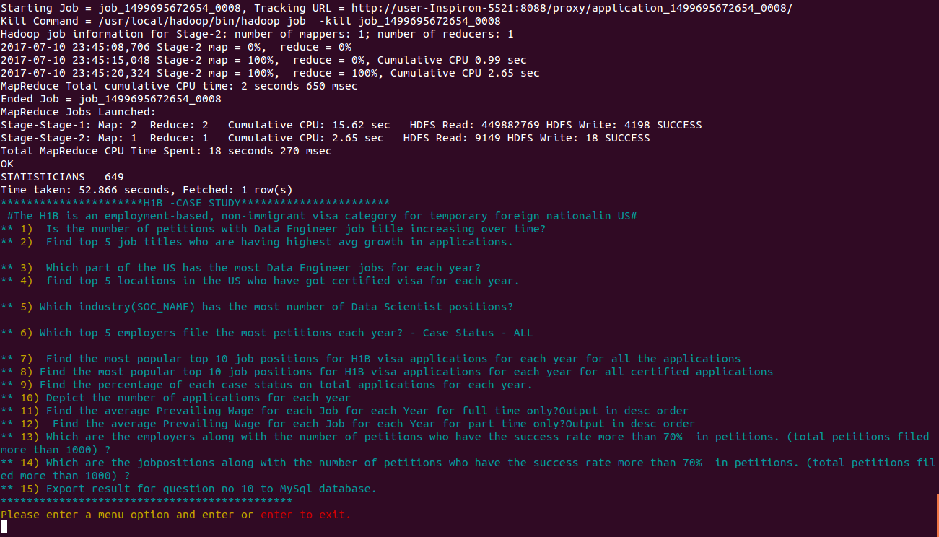

H1B Visa Applications Project
HIVE QUESTIONS:

1a) Is the number of petitions with Data Engineer job title increasing over time?

select year,job_title,count(year) from h1b_applications where job_title LIKE '%DATA ENGINEER%' group by year,job_title;

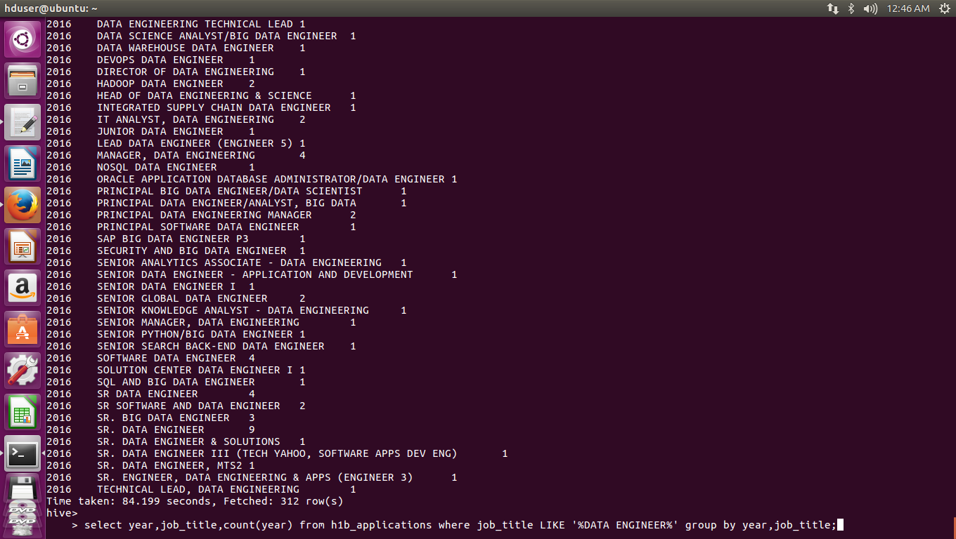
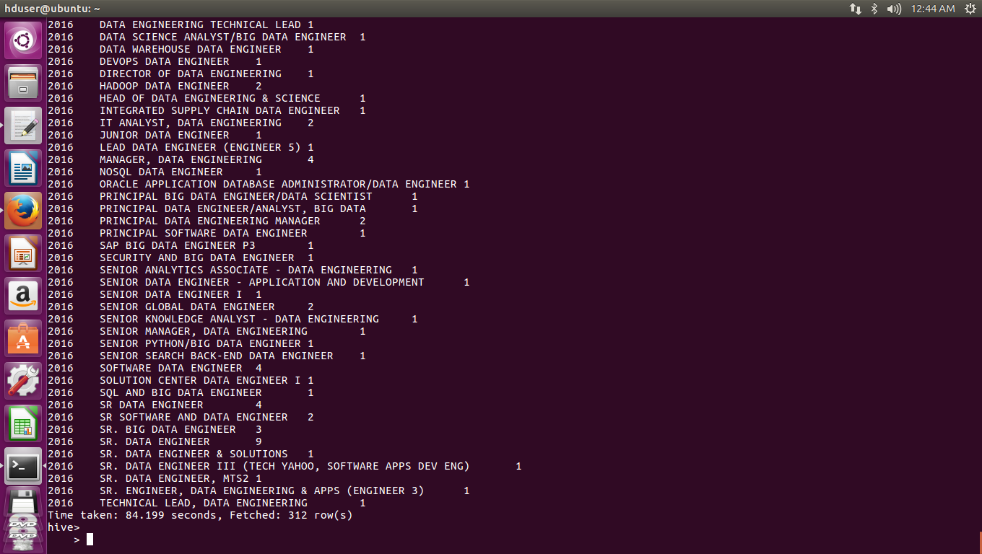

2.a) Which part of the US has the most Data Engineer jobs for each year?

select split(worksite,'[,]')[1] as state, job_title,count(split(worksite,'[,]')[1]) as job_cnt from h1b_applications where job_title LIKE '%DATA ENGINEER%' group by job_title,split(worksite,'[,]')[1] order by job_cnt desc;

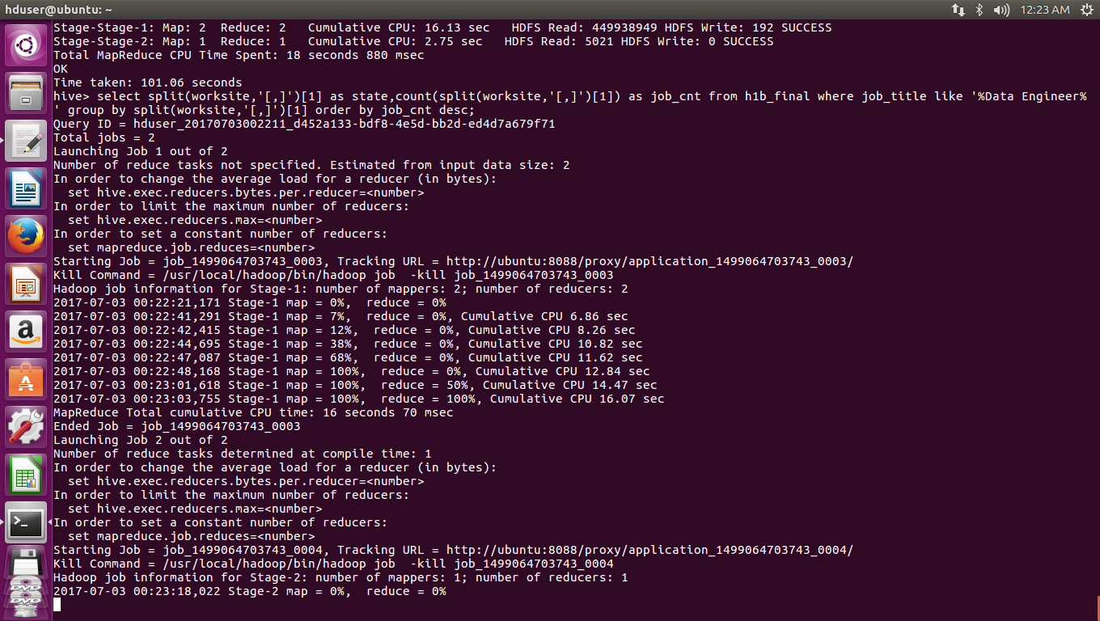
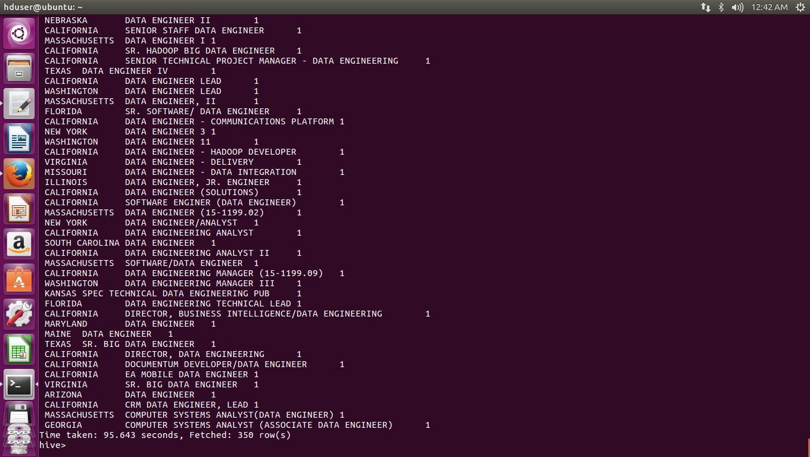
2.b) find top 5 locations in the US who have got certified visa for each year.

select worksite,year,count(worksite) as cnt,case_status from h1b_final where case_status ='CERTIFIED' and year='2011' group by worksite,year,case_status order by cnt desc limit 5;

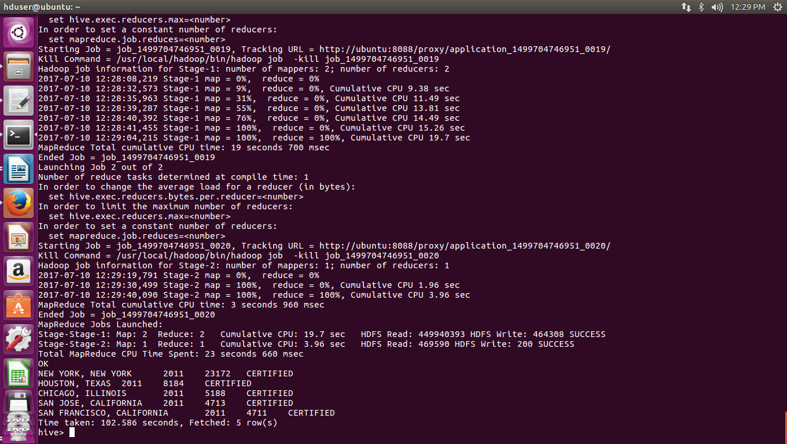

select worksite,year,count(worksite) as cnt,case_status from h1b_final where case_status ='CERTIFIED' and year='2012' group by worksite,year,case_status order by cnt desc limit 5;

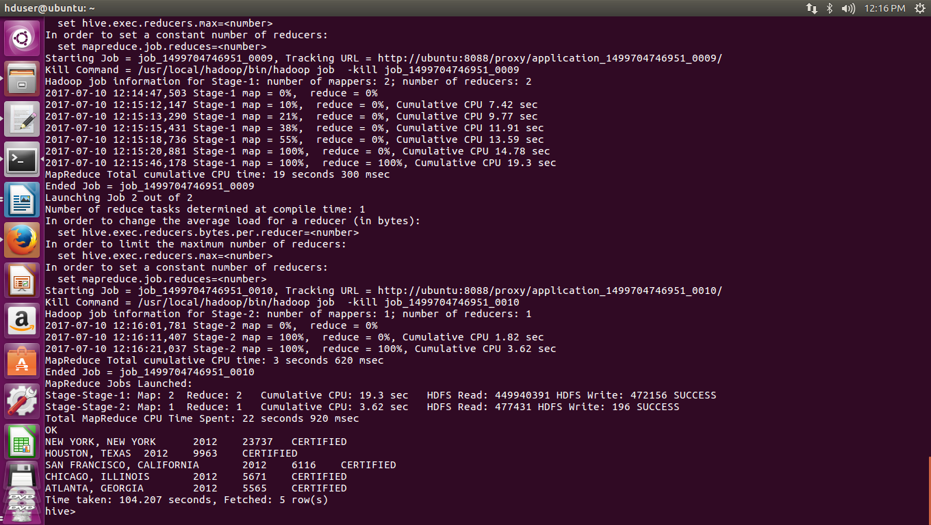

select worksite,year,count(worksite) as cnt,case_status from h1b_final where case_status ='CERTIFIED' and year='2013' group by worksite,year,case_status order by cnt desc limit 5;
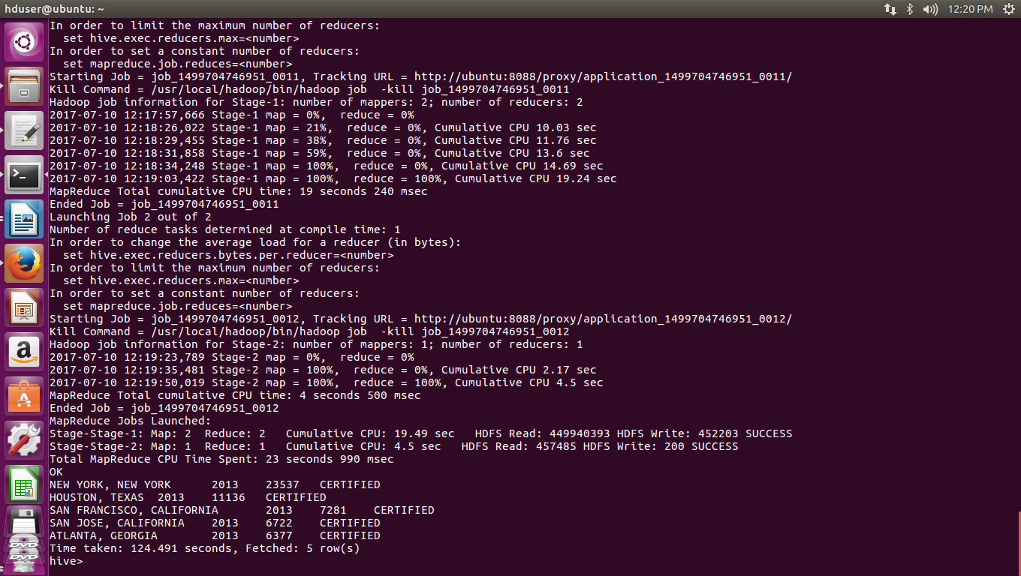

select worksite,year,count(worksite) as cnt,case_status from h1b_final where case_status ='CERTIFIED' and year='2014' group by worksite,year,case_status order by cnt desc limit 5;
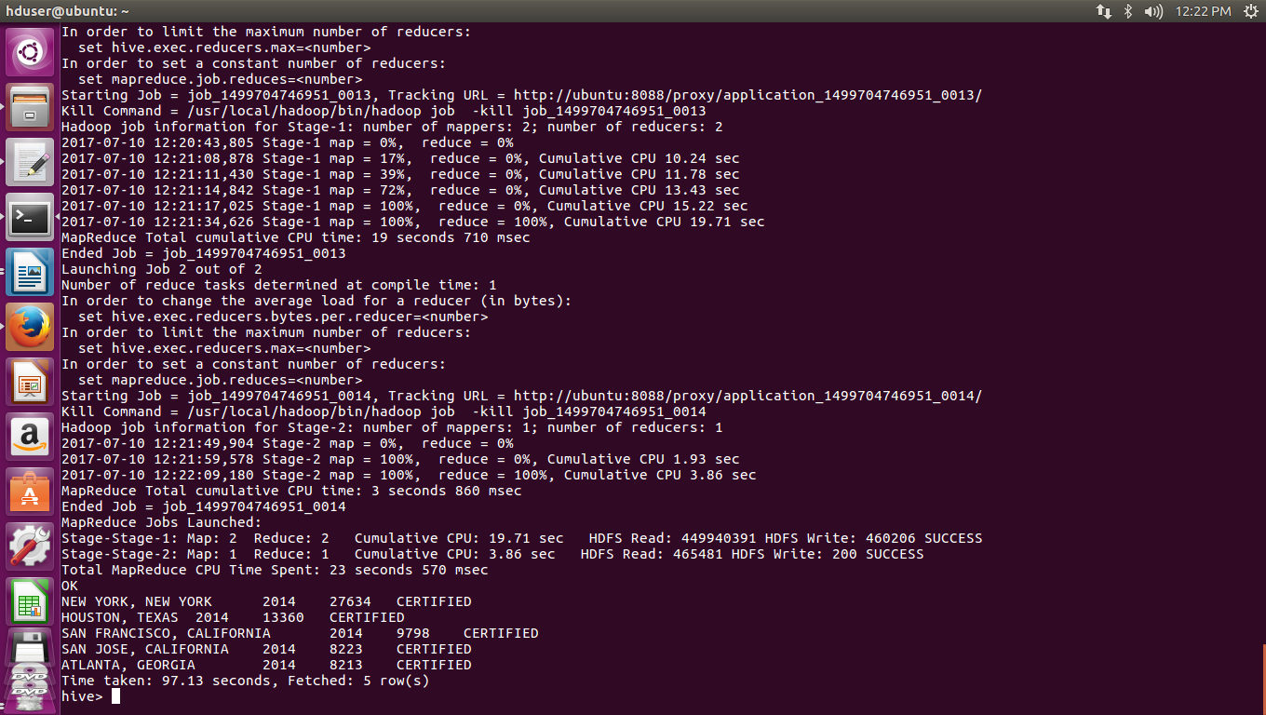

select worksite,year,count(worksite) as cnt,case_status from h1b_final where case_status ='CERTIFIED' and year='2015' group by worksite,year,case_status order by cnt desc limit 5;

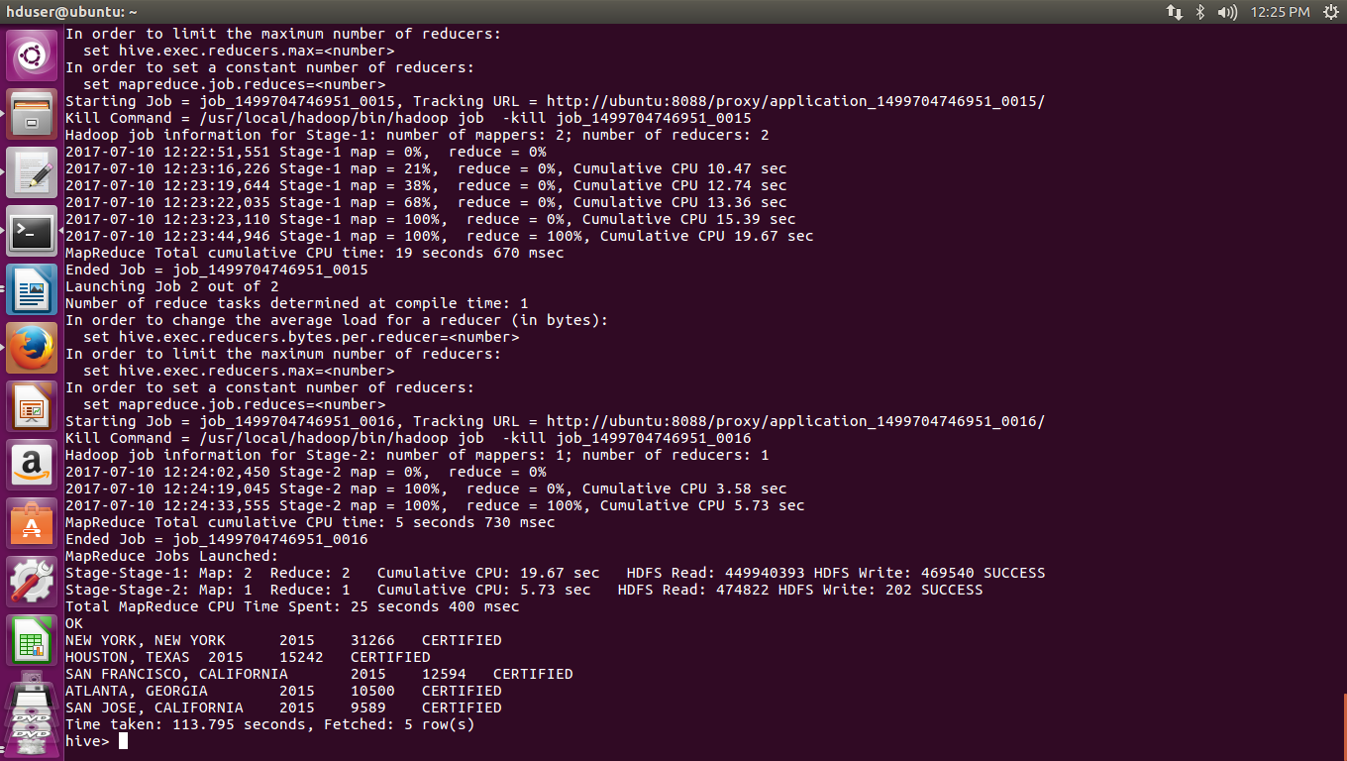

select worksite,year,count(worksite) as cnt,case_status from h1b_final where case_status ='CERTIFIED' and year='2016' group by worksite,year,case_status order by cnt desc limit 5;

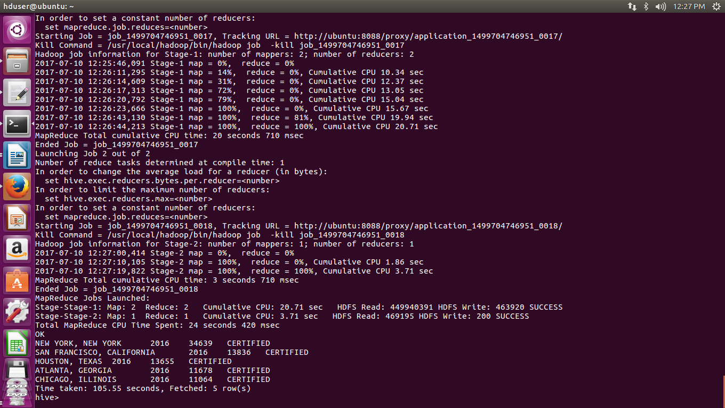

3)Which industry(SOC_NAME) has the most number of Data Scientist positions?

select soc_name ,count(soc_name) as cnt from h1b_final where job_title like '%Data Scientists%' group by soc_name order by cnt desc;

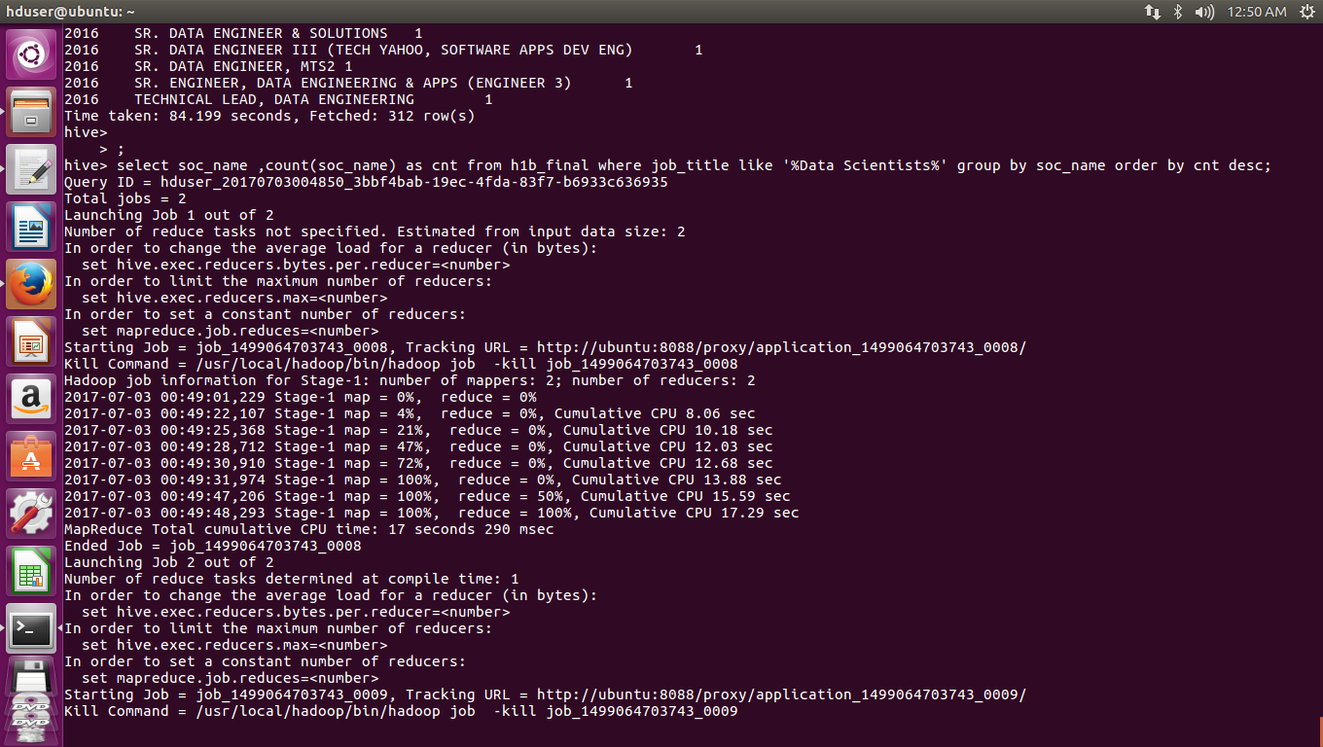



4)Which top 5 employers file the most petitions each year?

create table y21(ename string,year int,c_year int) row format delimited fields terminated by ',';

create table y22(ename string,year int,c_year int) row format delimited fields terminated by ',';

create table y23(ename string,year int,c_year int) row format delimited fields terminated by ',';

create table y24(ename string,year int,c_year int) row format delimited fields terminated by ',';

create table y25(ename string,year int,c_year int) row format delimited fields terminated by ',';

create table y26(ename string,year int,c_year int) row format delimited fields terminated by ',';

insert into table y21 select employer_name,year,count(year) as cyear from h1b_final where year= '2011' group by employer_name,year order by year desc limit 5;

insert into table y22 select employer_name,year,count(year) as cyear from h1b_final where year= '2012' group by employer_name,year order by year desc limit 5;

insert into table y23 select employer_name,year,count(year) as cyear from h1b_final where year= '2013' group by employer_name,year order by year desc limit 5;

insert into table y24 select employer_name,year,count(year) as cyear from h1b_final where year= '2014' group by employer_name,year order by year desc limit 5;

insert into table y25 select employer_name,year,count(year) as cyear from h1b_final where year= '2015' group by employer_name,year order by year desc limit 5;

insert into table y26 select employer_name,year,count(year) as cyear from h1b_final where year= '2016' group by employer_name,year order by year desc limit 5;
select * from y21 union all select * from y22 union all select * from y23 union all select * from y24 union all select * from y25 union all select * from y26 order by year;

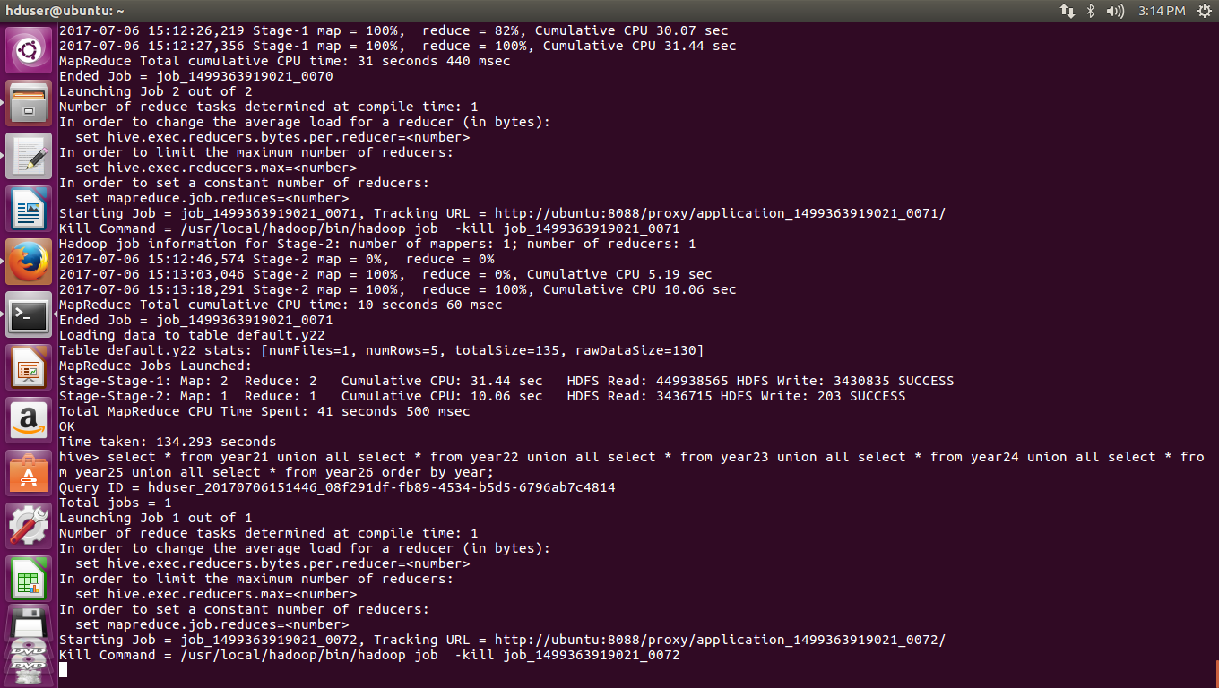
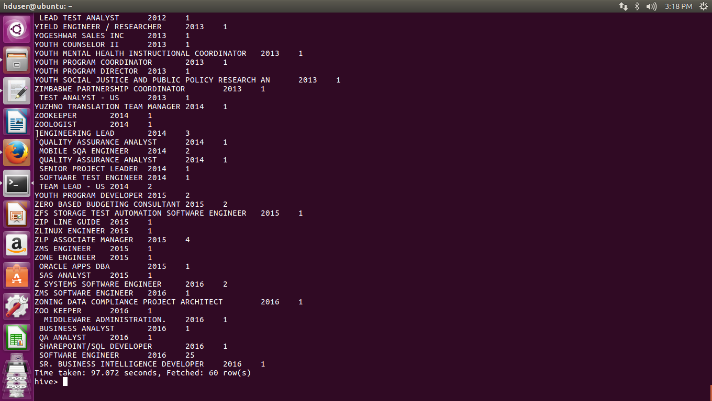

5) Find the most popular top 10 job positions for H1B visa applications for each year?

a) for all the applications

create table year21(jobs string,year int,cjob int) row format delimited fields terminated by ',';

create table year22(jobs string,year int,cjob int) row format delimited fields terminated by ',';

create table year23(jobs string,year int,cjob int) row format delimited fields terminated by ',';

create table year24(jobs string,year int,cjob int) row format delimited fields terminated by ',';

create table year25(jobs string,year int,cjob int) row format delimited fields terminated by ',';

create table year26(jobs string,year int,cjob int) row format delimited fields terminated by ',';

insert into table year21 select job_title,year,count(job_title) as cjob from h1b_final where year= '2011' group by job_title,year order by cjob desc limit 10;

insert into table year22 select job_title,year,count(job_title) as cnt from h1b_final where year= '2012' group by job_title,year order by cjobdesc limit 10;

insert into table year23 select job_title,year,count(job_title) as cjob from h1b_final where year= '2013' group by job_title,year order by cjob desc limit 10;

insert into table year24 select job_title,year,count(job_title) as cnt from h1b_final where year= '2014' group by job_title,year order by cjob desc limit 10;

insert into table year25 select job_title,year,count(job_title) as cnt from h1b_final where year= '2015' group by job_title,year order by cjob desc limit 10;

insert into table year26 select job_title,year,count(job_title) as cnt from h1b_final where year= '2016' group by job_title,year order by cjob desc limit 10;

select * from year21 union all select * from year22 union all select * from year23 union all select * from year24 union all select * from year25 union all select * from year26 order by year;

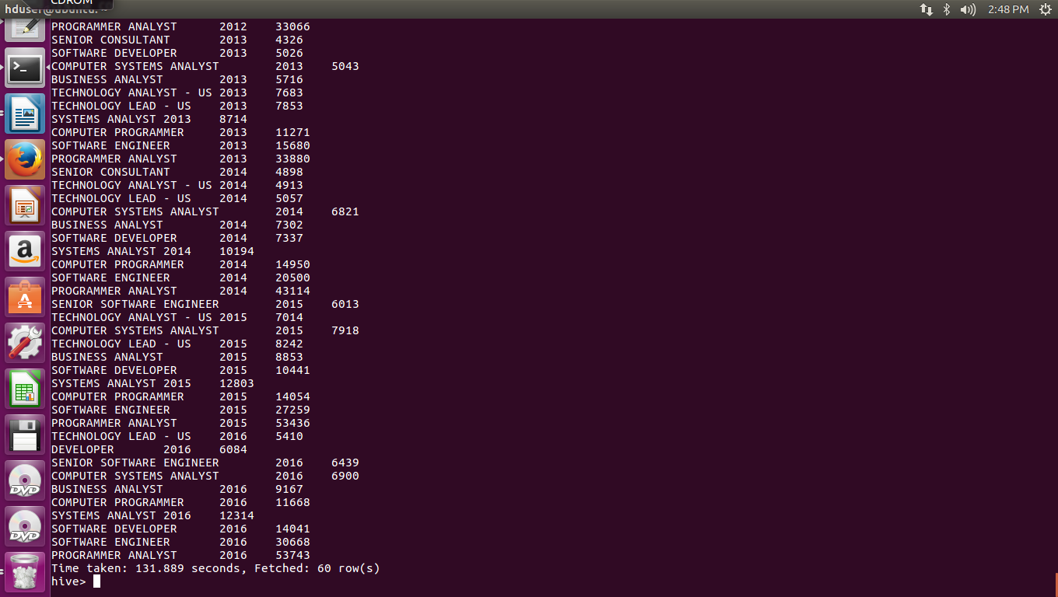

b) for only certified applications.

create table year11(jobs string,year int,cjob int,case_status string) row format delimited fields terminated by ',';

create table year12(jobs string,year int,cjob int,case_status string) row format delimited fields terminated by ',';

create table year13(jobs string,year int,cjob int,case_status string) row format delimited fields terminated by ',';

create table year14(jobs string,year int,cjob int,case_status string) row format delimited fields terminated by ',';

create table year15(jobs string,year int,cjob int,case_status string) row format delimited fields terminated by ',';

create table year16(jobs string,year int,cjob int,case_status string) row format delimited fields terminated by ',';

insert into table year11 select job_title ,year,count(job_title) as cjob ,case_status from h1b_final where case_status ='CERTIFIED' and year= '2011' group by job_title,year,case_status order by cjob desc limit 10;

insert into table year12 select job_title,year,count(job_title) as cjob,case_status from h1b_final where case_status ='CERTIFIED' and year= '2012' group by job_title,year,case_status order by cjob desc limit 10;

insert into table year13 select job_title,year,count(job_title) as cjob,case_status from h1b_final where case_status ='CERTIFIED' and year= '2013' group by job_title,year order by cjob desc limit 10;

insert into table year14 select job_title,year,count(job_title) as cjob,case_status from h1b_final where case_status ='CERTIFIED' and year= '2014' group by job_title,year,case_status order by cjob desc limit 10;

insert into table year15 select job_title,year,count(job_title) as cjob,case_status from h1b_final where case_status ='CERTIFIED' and year= '2015' group by job_title,year,case_status order by cjob desc limit 10;

insert into table year16 select job_title,year,count(job_title) as cjob,case_status from h1b_final where case_status ='CERTIFIED' and year= '2016' group by job_title,year,case_status order by cjob desc limit 10;

select * from year11 union all select * from year12 union all select * from year13 union all select * from year14 union all select * from year15 union all select * from year16 order by year;

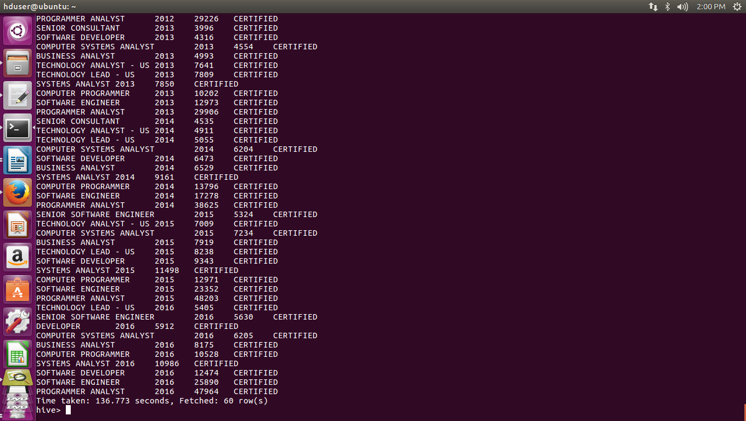
8) Find the average Prevailing Wage for each Job for each Year (take part time and full time separate). Arrange the output in descending order.

a) part time

select year,job_title,AVG(prevailing_wage) as average from h1b_final where full_time_position='N' and prevailing_wage is not null group by job_title,year order by average desc;
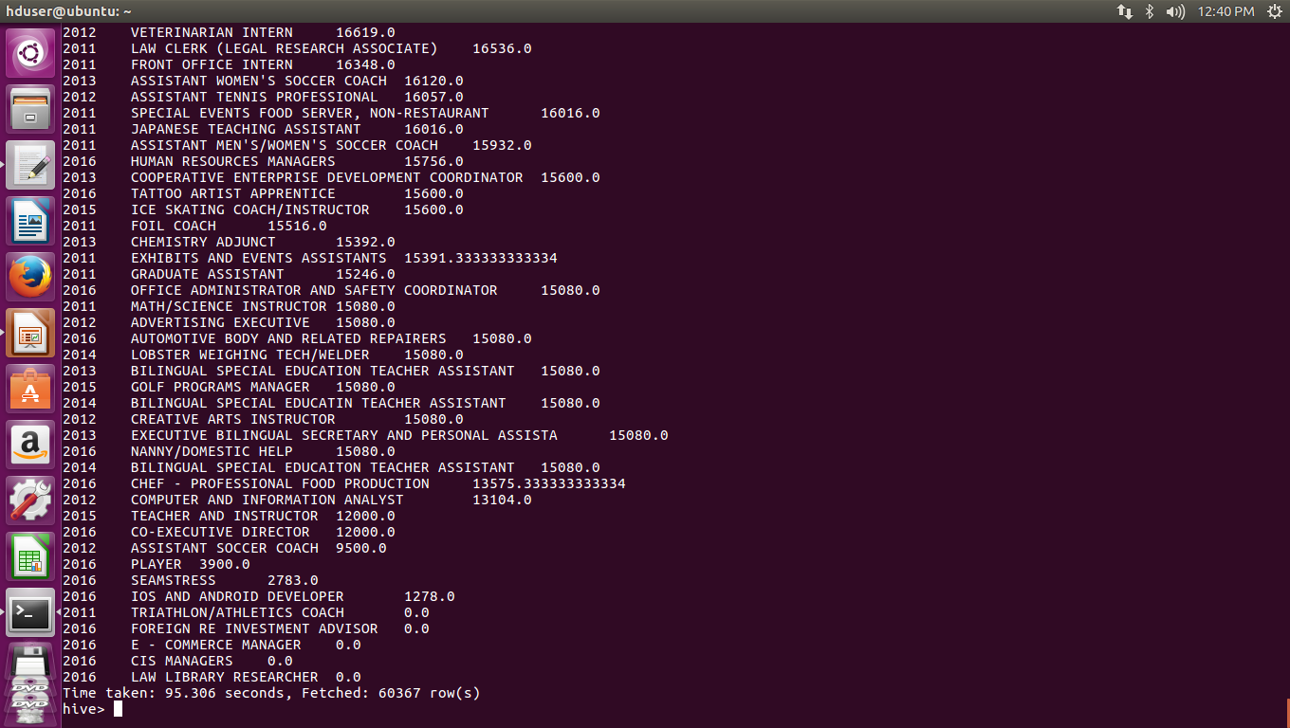

b) full time
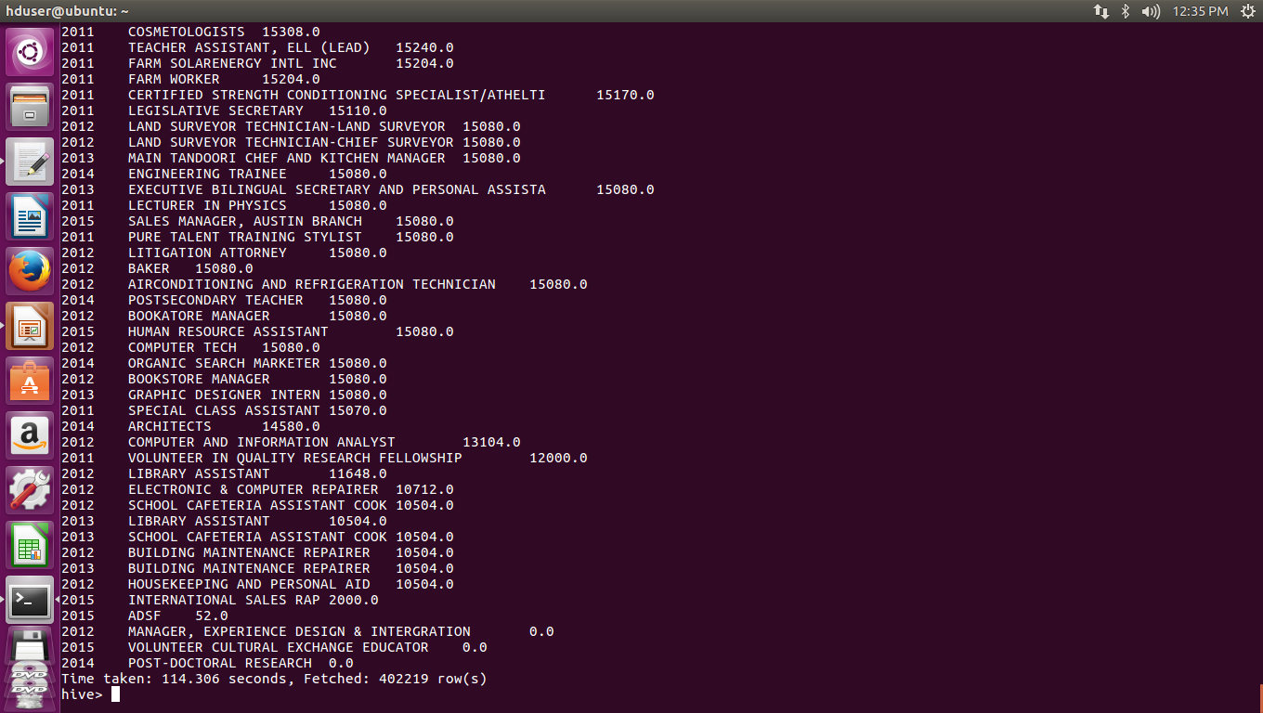
select year,job_title,AVG(prevailing_wage) as average from h1b_final where full_time_position='Y' and prevailing_wage is not null group by job_title,year order by average desc;

7.Create a bar graph to depict the number of applications for each year

select year,count(*) from h1b_final group by year order by year;

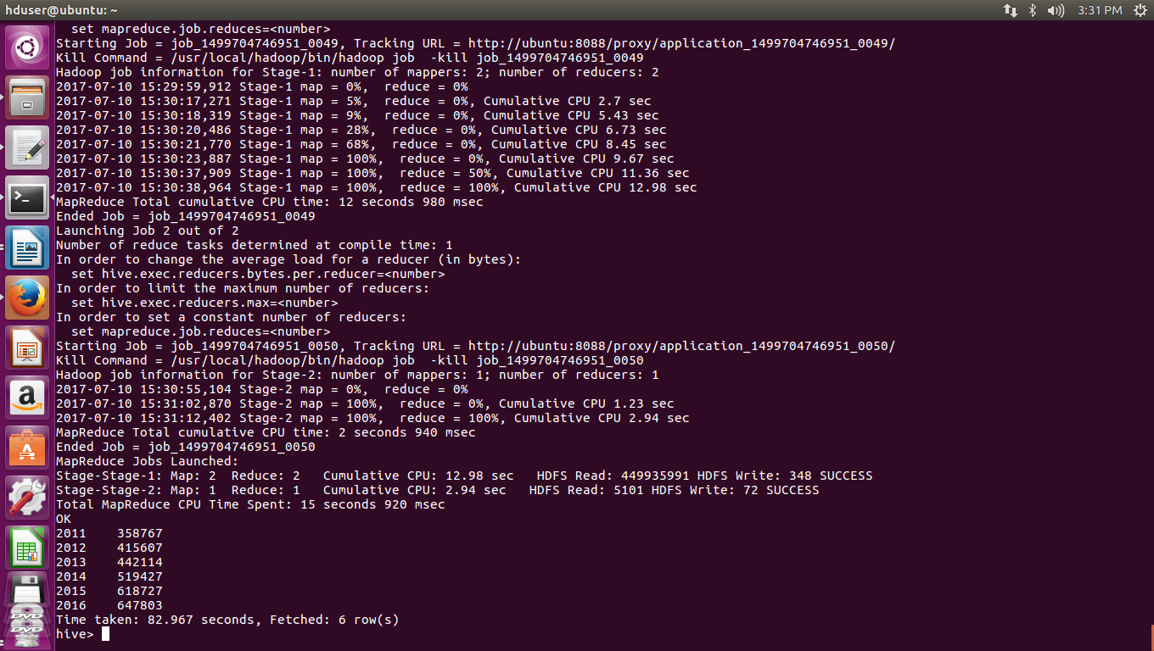

PIG QUESTIONS:
1. b) Find top 5 job titles who are having highest avg growth in applications.

bag=load '/user/hive/warehouse/h1b_final' using PigStorage() as (s_no:int,case_status:chararray,employer_name:chararray,soc_name:chararray,job_title:chararray,full_time_position:chararray,prevailing_wage:int,year:chararray,worksite:chararray,longitude:double,latitude:double);

p1= filter bag by $7 ==2011';
q1= group p1 by $4;
r1= foreach q1 generate group,COUNT($1);

p2= filter bag by $7 == '2012';
q2= group p2 by $4;
r2= foreach q2 generate group,COUNT($1);

p3= filter bag by $7 =='2013';
q3= group p3 by $4;
r3= foreach q3 generate group,COUNT($1);

p4= filter bag by $7 == '2014';
q4= group p4 by $4;
r4= foreach q4 generate group,COUNT($1);

p5= filter bag by $7 == '2015';
q5= group p5 by $4;
r5= foreach q5 generate group,COUNT($1);

p6= filter bag by $7 == '2016';
q6= group p6 by $4;
r6= foreach q6 generate group,COUNT($1);

joined= join r1 by $0,r2 by $0,r3 by $0,r4 by $0,r5 by $0,r6 by $0;
yearwiseapplications= foreach joined generate $0,$1,$3,$5,$7,$9,$11;

progressivegrowth= foreach yearwiseapplications generate $0,
(float)($6-$5)*100/$5,(float)($5-$4)*100/$4,
(float)($4-$3)*100/$3,(float)($3-$2)*100/$2,
(float)($2-$1)*100/$1;

avg_growth_percent = foreach growth_percent generate $0,(($1+$2+$3+$4+$5)/5);

order_agp = order avg_growth_percent by $1 desc;

top5 = limit order_agp 5;

dump top5;

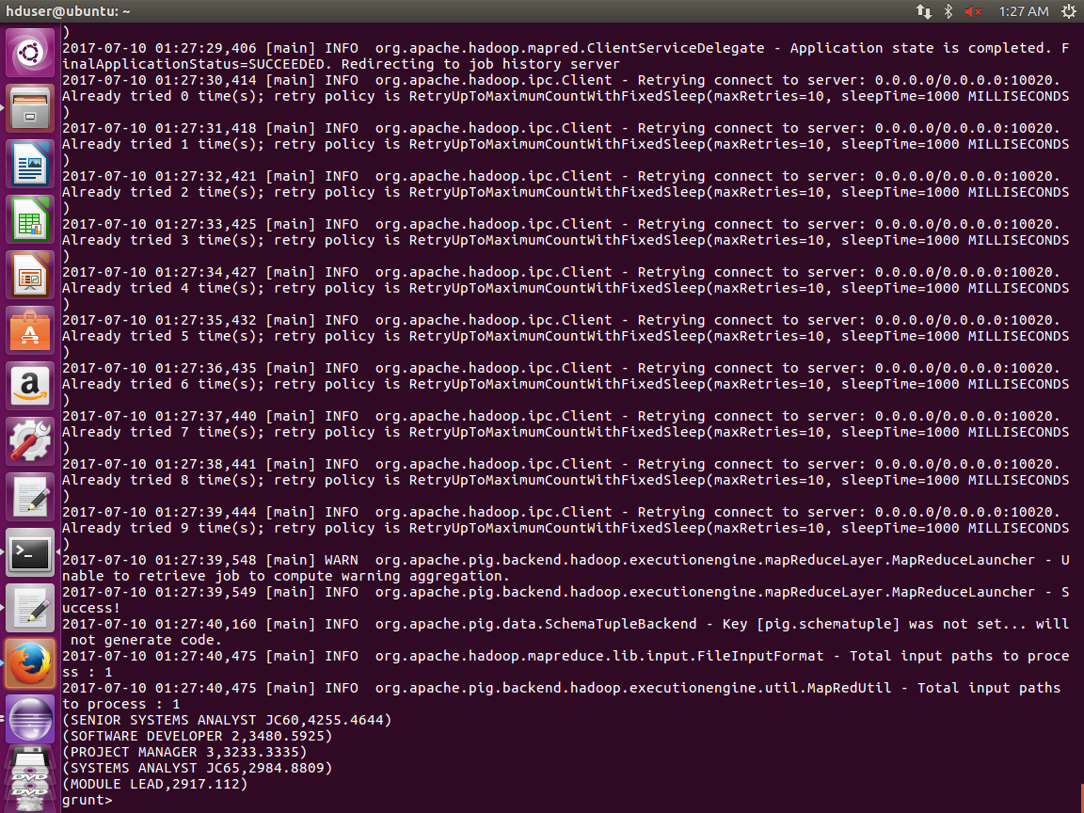

6.Find the percentage and the count of each case status on total applications for each year. Create a line graph depicting the pattern of All the cases over the period of time.

bag1 = load '/user/hive/warehouse/h1b_final' using PigStorage() as (s_no:int,case_status:chararray,employer_name:chararray,soc_name:chararray,job_title:chararray,full_time_position:chararray,prevailing_wage:int,year:int,worksite:chararray,long:double,lati:double);
bag2 = group bag1 by year ;
bag4 = foreach bag2 generate group as year,bag1.case_status;
bag5 = foreach bag4 generate year,FLATTEN($1);
split bag5 into bag6 if null::case_status =='CERTIFIED-WITHDRAWN',bag7 if null::case_status =='WITHDRAWN' ,bag8 if null::case_status =='CERTIFIED',bag9 if null::case_status =='DENIED';
bag10 = group bag6 by year ;
bag11 = group bag7 by year ;
bag12 = group bag8 by year;
bag13 = group bag9 by year;
bag14 = foreach bag10 generate group as year,COUNT(bag6.$1);
bag15 = foreach bag11 generate group as year,COUNT(bag7.$1);
bag16 = foreach bag12 generate group as year,COUNT(bag8.$1);
bag17 = foreach bag13 generate group as year,COUNT(bag9.$1);
bag18 =join bag14 by $0,bag15 by $0,bag16 by $0,bag17 by $0;
total = foreach bag18 generate $0,$1,$3,$5,$7,$1+$3+$5+$7;
dump total;
final = foreach total generate $0,((double)$1/$5*100),((double)$2/$5*100),((double)$3/$5*100),((double)$4/$5*100);
dump final;

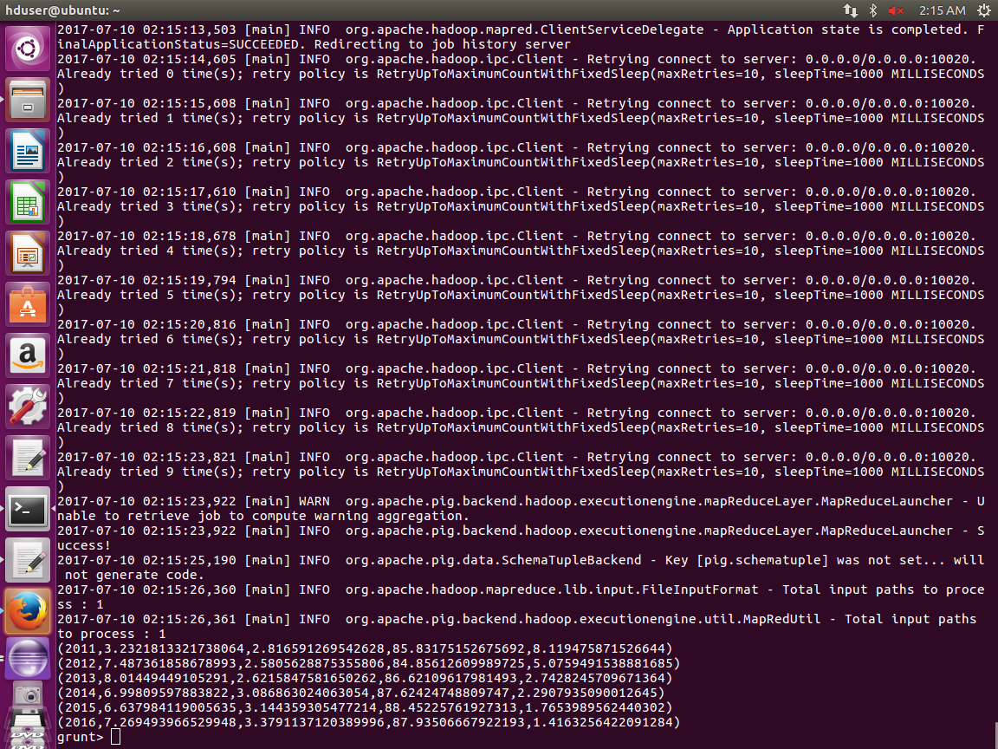

4)Which top 5 employers file the most petitions each year?

Bag1= load '/user/hive/warehouse/h1b_final' using PigStorage(',') as (s_no:int,case_status:chararray,employer_name:chararray,soc_name:chararray,job_title:chararray,full_time_position:chararray,prevailing_wage:int,year:int,worksite:chararray,longitude:double,latitude:double);
bag2 = group bag1 by (employer_name,year);
bag3 = foreach bag2 generate group,COUNT(bag1);
bag4 = foreach bag3 generate FLATTEN(group),$1;
split bag4 into bag5 if null::year ==2011,bag6 if null:: year ==2012,bag7 if null:: year ==2013,bag8 if null:: year ==2014,bag9 if null:: year ==2015,bag10 if null:: year ==2016;
dump bag5;
bag9 = order bag5 by $2 desc;
bag10 = limit bag9 5;
dump bag10;

MAPREDUCE QUESTIONS:

3)Which industry(SOC_NAME) has the most number of Data Scientist positions?

package finalproject;

import java.io.IOException;

import org.apache.hadoop.io.IntWritable;
import org.apache.hadoop.io.LongWritable;
import org.apache.hadoop.io.Text;
import org.apache.hadoop.mapreduce.Job;
import org.apache.hadoop.mapreduce.Mapper;
import java.util.TreeMap;
import org.apache.hadoop.io.NullWritable;
import org.apache.hadoop.mapreduce.Reducer;
import org.apache.hadoop.mapreduce.Mapper.Context;
import org.apache.hadoop.conf.Configuration;
import org.apache.hadoop.fs.Path;
import org.apache.hadoop.mapreduce.lib.input.FileInputFormat;
import org.apache.hadoop.mapreduce.lib.input.TextInputFormat;
import org.apache.hadoop.mapreduce.lib.output.FileOutputFormat;
import org.apache.hadoop.mapreduce.lib.output.TextOutputFormat;

public class soc_name3 {

public static class MapClass extends Mapper<LongWritable,Text,Text,IntWritable>{
public void map(LongWritable key,Text value,Context context) throws IOException, InterruptedException{
try{
String[] parts = value.toString().split("/t");
String industry = parts[2];
String job = parts[4];
int count = 1;
if(job.equals("\"DATA SCIENTIST\"")){
context.write(new Text(industry),new IntWritable(count));

}
else
{
System.out.println("error");
}
}
catch(ArrayIndexOutOfBoundsException e){
System.out.println(e);
}

}

public static class ReduceClass extends Reducer<Text,IntWritable,NullWritable,Text>{
private TreeMap<Integer,Text> highest = new TreeMap<>();
public void reduce(Text key,Iterable<IntWritable> value,Context context) throws IOException, InterruptedException{
int count = 0;
for (IntWritable val:value){
count += val.get();
}
String output = key.toString()+","+count;
highest.put(count,new Text(output));
if(highest.size()>1){
highest.remove(highest.firstKey());
}
}
protected void cleanup(Context context) throws IOException, InterruptedException{
for(Text t:highest.values()){
context.write(NullWritable.get(),t);
}
}
}

public static void main(String[] args) throws IOException, ClassNotFoundException, InterruptedException{
Configuration conf = new Configuration();
conf.set("mapreduce.output.textoutputformat.separator", ",");
Job job = Job.getInstance(conf, "h1b3");
job.setJarByClass(soc_name3.class);
job.setMapperClass(MapClass.class);
job.setReducerClass(ReduceClass.class);
job.setMapOutputKeyClass(Text.class);
job.setMapOutputValueClass(IntWritable.class);
job.setOutputKeyClass(NullWritable.class);
//job.setNumReduceTasks(0);
//job.setCombinerClass(ReduceClass.class);
job.setOutputValueClass(Text.class);
job.setInputFormatClass(TextInputFormat.class);
job.setOutputFormatClass(TextOutputFormat.class);
FileInputFormat.addInputPath(job, new Path(args[0]));
FileOutputFormat.setOutputPath(job, new Path(args[1]));
System.exit(job.waitForCompletion(true) ? 0 : 1);
}

}
}

7. Create a bar graph to depict the number of applications for each year

package image;

import org.apache.hadoop.io.IntWritable;
import org.apache.hadoop.io.Text;
import org.apache.hadoop.io.LongWritable;
import org.apache.hadoop.mapreduce.Job;
import org.apache.hadoop.mapreduce.Mapper;
import org.apache.hadoop.mapreduce.Reducer;
import org.apache.hadoop.conf.*;
import org.apache.hadoop.fs.*;
import org.apache.hadoop.mapreduce.lib.input.*;
import org.apache.hadoop.mapreduce.lib.output.*;
import java.io.*;

public class projectmap {

public static class h1bMapper extends Mapper<LongWritable,Text,Text,IntWritable>
{
public void map(LongWritable key,Text value,Context context)
{
try{
String[] str =value.toString().split("\t");

context.write(new Text(str[7]),new IntWritable(1));}
catch(Exception e)
{
System.out.println(e.getMessage());
}

}
}

public static class h1bReducer extends Reducer<Text,IntWritable,Text,IntWritable>
{
IntWritable result = new IntWritable();

public void reduce(Text key, Iterable<IntWritable> values,Context context) throws IOException, InterruptedException {
int sum = 0;

for (IntWritable val : values)
{
sum += val.get();
}

result.set(sum);
context.write(key, result);

}
}

/**
* @param args
* @throws IOException
* @throws IllegalArgumentException
* @throws InterruptedException
* @throws ClassNotFoundException
*/
public static void main(String[] args) throws Exception{
Configuration conf = new Configuration();
//conf.set("name", "value");

Job job=Job.getInstance(conf, "count");
job.setJarByClass(projectmap.class);
job.setReducerClass(h1bReducer.class);
job.setMapperClass(h1bMapper.class);
job.setNumReduceTasks(1);
job.setOutputKeyClass(Text.class);
job.setOutputValueClass(IntWritable.class);
FileInputFormat.addInputPath(job, new Path(args[0]));
FileOutputFormat.setOutputPath(job,new Path(args[1]));
System.exit(job.waitForCompletion(true) ? 0 : 1);

}

// TODO Auto-generated method stub

}

/**
* @param args
*/

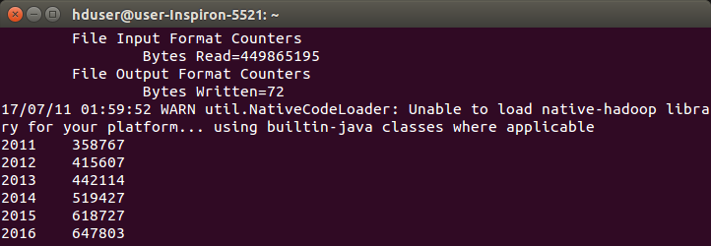

9.Which are the employers along with the number of petitions who have the success rate more than 70% in petitions. (total petitions filed more than 1000) ?

package finalproject;

import java.io.IOException;
import java.util.TreeMap;

import org.apache.hadoop.conf.Configuration;
import org.apache.hadoop.fs.Path;
import org.apache.hadoop.io.LongWritable;
import org.apache.hadoop.io.NullWritable;
import org.apache.hadoop.io.Text;
import org.apache.hadoop.mapreduce.Job;
import org.apache.hadoop.mapreduce.Mapper;
import org.apache.hadoop.mapreduce.Reducer;
import org.apache.hadoop.mapreduce.lib.input.FileInputFormat;
import org.apache.hadoop.mapreduce.lib.output.FileOutputFormat;

public class success {

public static class MapperEx extends Mapper<LongWritable, Text, Text, Text> {

public void map(LongWritable key, Text value, Context c)throws IOException, InterruptedException {
try{
String Line = value.toString();
String[] arr =Line.split("\t");
String case_status = arr[1];
String employer_name = arr[2];

c.write(new Text(employer_name), new Text(case_status));

}
catch(ArrayIndexOutOfBoundsException e1)
{
System.out.println(e1);
}
}

public static class ReducerEx extends Reducer<Text,Text,NullWritable,Text>{
private TreeMap<Double, String> Emp_success = new TreeMap<Double, String>();
public void reduce(Text key, Iterable<Text> value, Context c){

double total =0;
double sum=0;
for (Text val:value)
{
String case_status = val.toString();
if(case_status.equals("CERTIFIED") || case_status.equals("CERTIFIED WITHDRAWN"))
{
total++ ;//if above status is found increase total
sum++;//increment count of only cer and cer-wd status
}
else
total++;//if other cases are found increase total anyway
}
double per = (sum/total)*100;
if(per >=70 && total >=1000){
String op = key.toString();
op = op + ',' + total+ ','+per;

Emp_success.put(per, op);
}

}
protected void cleanup(Context c) throws IOException, InterruptedException{
for(String val : Emp_success.descendingMap().values()){
c.write(NullWritable.get(),new Text(val));
}

}
}

public static void main(String[] args) throws ClassNotFoundException, IOException, InterruptedException {
Configuration conf =new Configuration();
Job job=Job.getInstance(conf,"Employers having success rate more than 70%");

job.setJarByClass(success.class);
job.setMapperClass(MapperEx.class);
job.setReducerClass(ReducerEx.class);

job.setOutputKeyClass(NullWritable.class);
job.setOutputValueClass(Text.class);
job.setMapOutputKeyClass(Text.class);
job.setMapOutputValueClass(Text.class);

FileInputFormat.addInputPath(job, new Path(args[0]));
FileOutputFormat.setOutputPath(job,new Path(args[1]));
System.exit(job.waitForCompletion(true) ? 0 : 1);

}

}
}

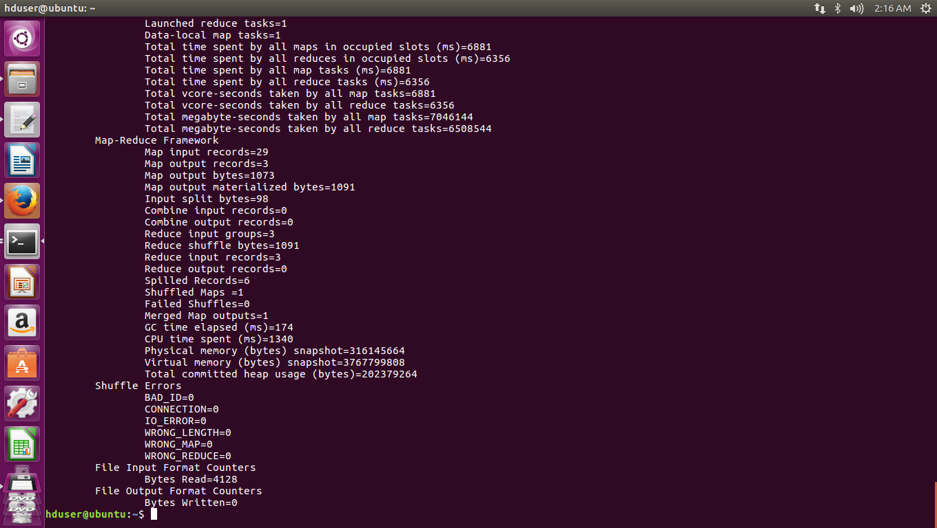

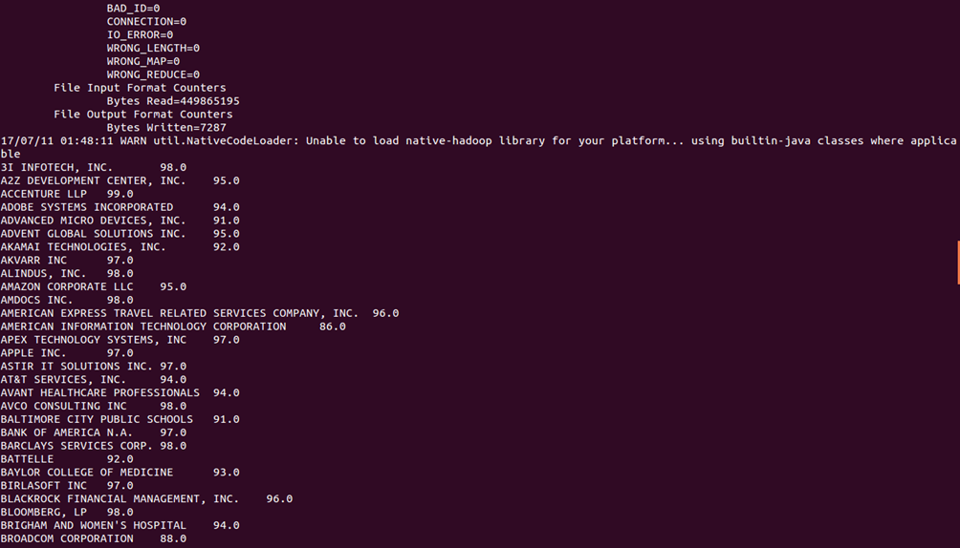



10.Which are the job positions along with the number of petitions which have the success rate more than 70% in petitions (total petitions filed more than 1000)?

package finalproject;

import java.io.IOException;
import java.util.TreeMap;

import org.apache.hadoop.conf.Configuration;
import org.apache.hadoop.fs.Path;
import org.apache.hadoop.io.LongWritable;
import org.apache.hadoop.io.NullWritable;
import org.apache.hadoop.io.Text;
import org.apache.hadoop.mapreduce.Job;
import org.apache.hadoop.mapreduce.Mapper;
import org.apache.hadoop.mapreduce.Reducer;
import org.apache.hadoop.mapreduce.Reducer.Context;
import org.apache.hadoop.mapreduce.lib.input.FileInputFormat;
import org.apache.hadoop.mapreduce.lib.output.FileOutputFormat;

import finalproject.success.MapperEx;
import finalproject.success.MapperEx.ReducerEx;

public class successjob {

public static class MapperExample extends Mapper<LongWritable, Text, Text, Text> {

public void map(LongWritable key, Text value, Context c)throws IOException, InterruptedException {
try{
String Line = value.toString();
String[] arr =Line.split("\t");
String case_status = arr[1];
String job_title = arr[4];

c.write(new Text(job_title), new Text(case_status));

}
catch(ArrayIndexOutOfBoundsException e1)
{
System.out.println(e1);
}
}

public static class ReducerExample extends Reducer<Text,Text,NullWritable,Text>{
private TreeMap<Double, String> Emp_success = new TreeMap<Double, String>();
public void reduce(Text key, Iterable<Text> value, Context c){

double total =0;
double sum=0;
for (Text val:value)
{
String case_status = val.toString();
if(case_status.equals("CERTIFIED") ||case_status.equals("CERTIFIED WITHDRAWN"))
{
total++ ;//if above status is found increase total
sum++;//increment count of only cer and cer-wd status
}
else
total++;//if other cases are found increase total anyway
}
double per = (sum/total)*100;
if(per >=70 && total >=1000){
String op = key.toString();
op = op + ',' + total+ ','+per;

Emp_success.put(per, op);
}

}
protected void cleanup(Context c) throws IOException, InterruptedException{
for(String val : Emp_success.descendingMap().values()){
c.write(NullWritable.get(),new Text(val));
}

}
}

public static void main(String[] args) throws ClassNotFoundException, IOException, InterruptedException {
Configuration conf =new Configuration();
Job job=Job.getInstance(conf,"job_title having success rate more than 70%");

job.setJarByClass(successjob.class);
job.setMapperClass(MapperExample.class);
job.setReducerClass(ReducerExample.class);

job.setOutputKeyClass(NullWritable.class);
job.setOutputValueClass(Text.class);
job.setMapOutputKeyClass(Text.class);
job.setMapOutputValueClass(Text.class);

FileInputFormat.addInputPath(job, new Path(args[0]));
FileOutputFormat.setOutputPath(job,new Path(args[1]));
System.exit(job.waitForCompletion(true) ? 0 : 1);

}

}

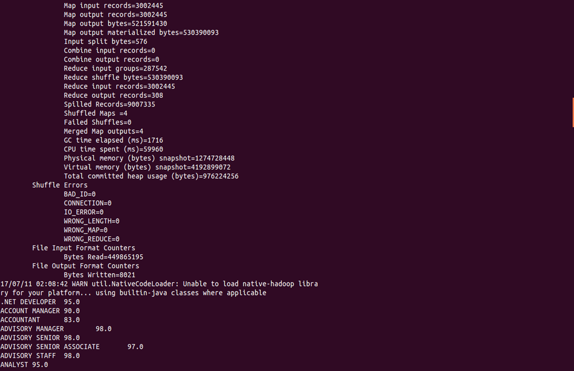

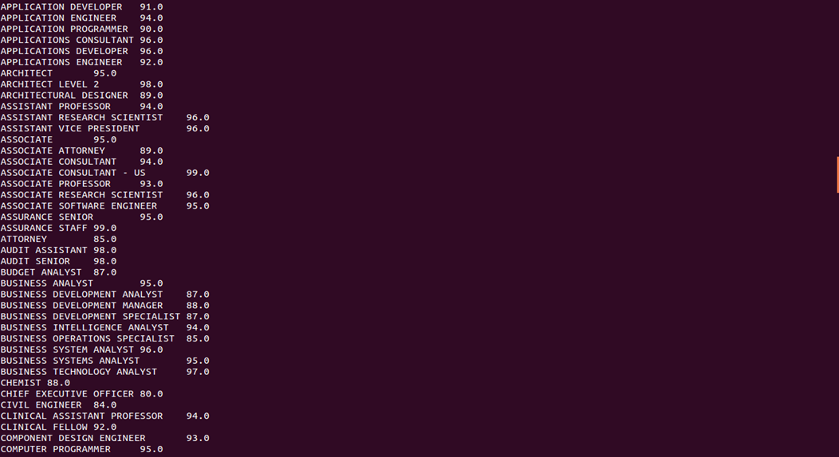

SQOOP QUESTION

11. Export result for question no 10 to MySql database.

sqoop export --connect jdbc:mysql://localhost/employee --username root --password 'sairam' --table exportAns10 --update-mode allowinsert --update-key employee_id --export-dir /niit/employee.txt --input-fields-terminated-by '\t' ;

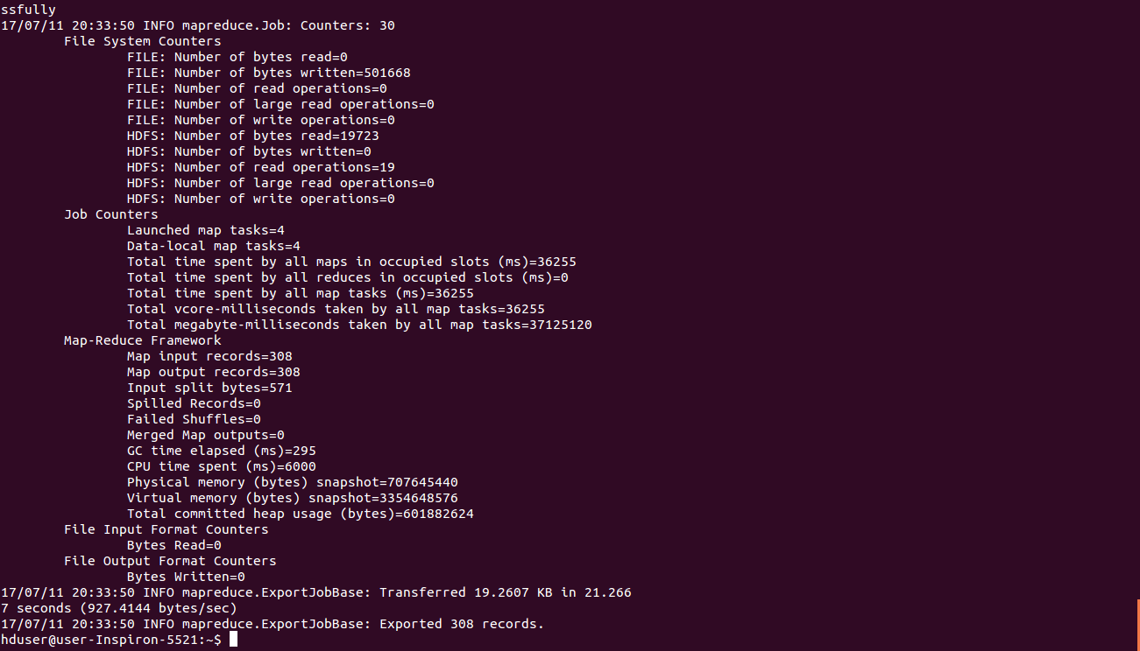

CONCLUSIONS:

1.All the questions can be solved by all the three tools Hive,Pig,Mapreduce but in order to avoid some complexity we solve some questions using some specific tool among all the three tools of hadoop.

2.In order to filter the data , for count operations we can use pig because pig is very efficient for these operations.

3.Hive is a query language we can handle queries using hive even finding count and percentage can be done using hive but it becomes very complicated so we prefer Pig.

4.We can write mapreduce programs using python,Ruby,Java ,C++ among these languages we used java to complete our task it makes the complex data analysis quite easy

5.Among all the Industries MICROSOFT CORPORATION has highest number of Data Scientist Postions

6.Among all the three using Hive and Pig it is quite easy to retrieve data and the coding is not much required for these two languages .

